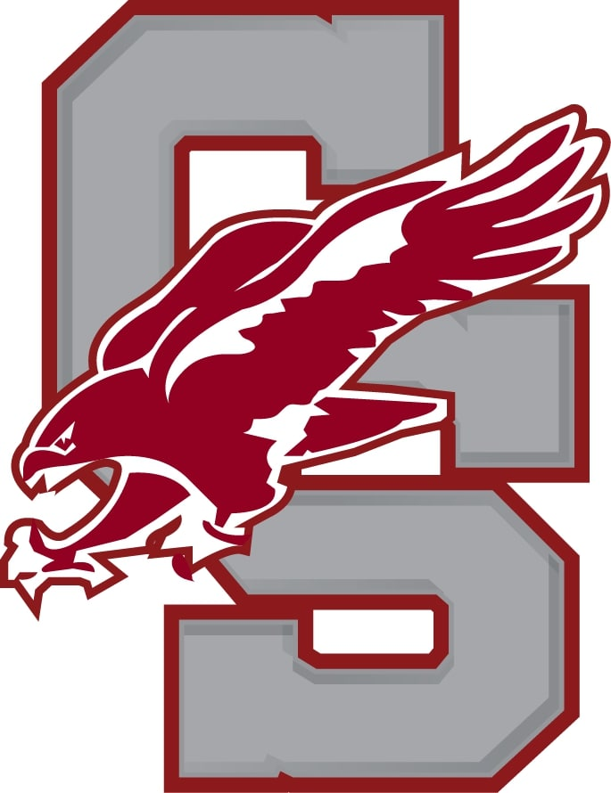Varsity Girls Soccer Pre-Season Info

Our first day of **tryouts will be held on August 26th from 8-11 AM at the Stadium**. From there we will continue to train on the turf for the following dates (8/27, 8/28, 8/29, 8/30, 8/31, 9/2) and our first game is on 9/3. Schedule Galaxy is updated with [our schedule](https://www.schedulegalaxy.com/schools/22/teams/6706?year=2024) for the season.

* In order to **sign up for tryouts** please sign up through the following link:

<http://account.students.arbitersports.com>

* **All players need a sports physical** by their physician or through the school before the season starts. Players cannot participate until their physical is completed, sent to the nurse and the nurse approves them (this will be shown on Arbiter).
* Summer opportunities to train are as follows:

Girls Soccer - CS Turf - 8:00 a.m. to 10:00 a.m.

Wednesdays & Thursdays - June 27th - August 22nd

**JUNE 27th will be 10 a.m. to 12 p.m.**

* Please come prepared to train with shin guards, water, and appropriate footwear.

If you wish to have a healthy, productive and successful Fall soccer season, it is extremely important that you begin tryouts with excellent physical fitness. The short time between tryouts and the competitive season is far too short to build significant strength, speed, endurance and agility. These are qualities that you must slowly build between now and mid-August. A well rounded program of endurance, strength, speed, agility and ball skills, completed over the summer, will allow you to begin the school season in top physical form. This will help reduce injury risks, maximize your individual performance and our team performance this Fall.

* Please [click link](https://docs.google.com/document/d/1ZGimuHzip5_6cJ4t9FokhrFJQGAGAfgc3zFPcue9k-o/edit) for an in depth training regiment for the off season (actual link is listed below, you can screenshot it to access if you are having issues)
* [**https://docs.google.com/document/d/1ZGimuHzip5_6cJ4t9FokhrFJQGAGAfgc3zFPcue9k-o/edit**](https://docs.google.com/document/d/1ZGimuHzip5_6cJ4t9FokhrFJQGAGAfgc3zFPcue9k-o/edit)

We are looking forward to this upcoming season. If you have any questions or concerns, please do not hesitate to contact Coach Feinberg.

Sincerely,

Ben Feinberg & Haley Imbesi

315-447-9212 or email bfeinberg@cssdapps.org