Tennis Study Guide

Terminology
Ace – a good serve that the receiver is unable to touch with his racquet
Advantage – the point after deuce
Backhand – hitting the ball, after the bounce, on your non-dominant side
Deuce – when the score is 40-40
Fault – a service failure where the ball does not land in the proper service court
or isn’t served in the proper manner
Foot Fault – When the server’s foot is on or over the baseline before the racquet
contacts the tossed ball prior to serving or when the server’s foot is
beyond the imaginary extension of the single’s sideline in singles or the
doubles sideline in doubles
Forehand – hitting the ball, after the bounce, on the dominant side of the body
Let – A serve that hits the net but lands into the proper service box; also any
point that is replayed. Following a service let the server is entitled to
re-serve that serve.
Love – zero points
Match – a series of sets determined by the best out of 3 or 5
Rally – a series of good hits made in succession by players.
Serve – the shot that begins a point. The ball must be hit in the air and land in
the correct service box.
Set – a scoring unit awarded to a player or team that has won: six or more
games and has a two game lead or six games and a tie break when
played at six-all
Smash – a hard overhead shot, sometimes referred to as an overhead
Volley – a stroke made by hitting the ball received from an opponent before it
has touched the ground

Official Scoring
0 points = “love”
1 point = 15
2 points = 30
3 points = 40
4 points = game

The winner of the first point gets “15”. The loser gets “0”, which is called love. You always say the server’s score first. If the server wins the first point, the score is “15-love”. If the server loses the first point the score is “love-15”.

Deuce and Advantage
40-40 = “deuce”
server wins point after deuce = advantage in
receiver wins point after deuce = advantage out

If the score is tied 40-40, it is called deuce. A player must win two points in a row after deuce to win a game. If the receiver wins the point after deuce, the score is advantage out. If neither player can win two points in a row after deuce, the score goes back to deuce again.

Sets and matches
The first player to win at least 6 games and be ahead by at least 2 games wins a set. 6-4 is a complete set, or 7-5. The first person to win 2 sets wins a match.

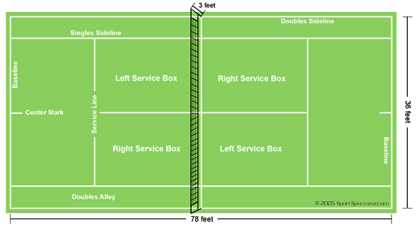

Playing the Game
- Tennis is played with 1 (singles) or 2 (doubles) players on each side of the net.
- The person to serve the first game is determined by a spin of the racquet.
- The server serves an entire game before giving the serve to the opponent.
- Service always starts in the right court and alternates right to left until the game is completed.
- Points can be scored by either the server or the receiver.
Tennis Etiquette
- Players are responsible for calling the lines on their side of the court and are expected to be fair and prompt in doing so.
- Any doubt as to whether a ball was out or good must be called good.
- To avoid controversy over scoring the server is responsible for calling out the score clearly before serving each point.
- Wait until the players on other courts have completed appoint before attempting to retrieve stray balls or passing through their court.
- Avoid verbal outbursts and profanity when playing or observing a tennis match.
- Shake hands with your partner and opponent at the end of a match.

